Lower Limb and Genital Lymphoedema Questionnaire for Men (LLGLQm)
Self-completion questionnaire for men who have lower limb oedema and/or genital area oedema / Lymphoedema.
Today’s date: _____________

Name, contact details and DoB or hospital number:
Swelling in the legs / genitals can be quite normal for a few weeks after some treatments or with some chronic conditions. Sometimes these can be difficult to describe but this questionnaire may help. Please complete the questions below to help us give you the appropriate advice and care.
Personal Impact  Over the last month how has the swelling affected your daily activities: |  |  | Not at all  (or not relevant)  0 | A little bit  1 | Quite a bit  2 | Very much  3
Please give one tick per row (for example)
I have swelling: |  | in my leg(s)
 |  | in my genitals
If you feel you have no swelling at all you do not need to complete the rest of this questionnaire.
The swelling is worse by the end of the day
The swelling is affecting: |  | which clothes/shoes I can wear
 |  | my sitting
 |  | getting in/out of bed
 |  | my walking
 |  | passing urine
 |  | my sexual function
The skin around the swollen area: |  | feels tight
 |  | has changed colour
 |  | feels different
 |  | feels wet/cold
The swelling gives me discomfort: |  | in my leg(s)
 |  | in my genitals
I regularly need to take painkillers for the discomfort
Please continue overleaf/next page.
Therapist to calculate after completion | Score for Personal Impact Section (score above / 48) x 100= % limited

On average this week how severe has the swelling been?
 | 0 =No swelling | 1 = a little bit | 2 = quite a bit | 3 = very swollen
Legs
Genitals
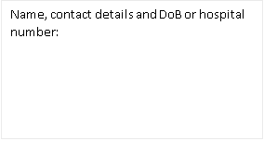
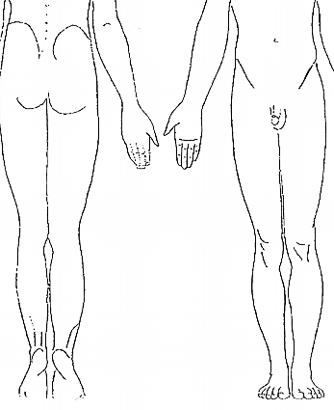
Is there anything else you would like to tell us about how this is affecting you physically or emotionally?

 | Yes | No
During the last year, have you needed antibiotics for infections (cellulitis) in your leg(s) or genitals?
Have you been offered any advice or treatment for the things you have identified here?
Would you like to discuss this with us?
Nurse/therapist to complete:
Name of nurse/therapist ____________________ has discussed this form with the patient. Signed:_________________________Date:_____________

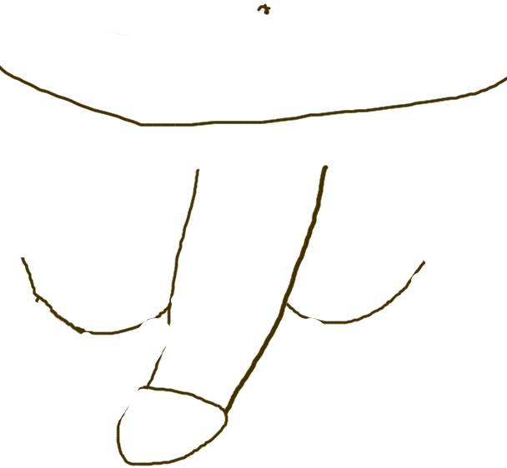
If you have swelling of your legs or genitals please show in this picture where it is, by shading like this:

