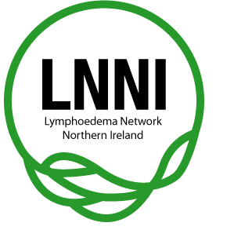

Lymphoedema Network Northern Ireland (LNNI)

Annual Report 2011/12

Agreement Cover Sheet

This annual report has been agreed by:

Chair of LNNI Board
Name: Mrs Clare McGartland
Date agreed June 2012

LNNI Project Lead
Name: Ms Jane Rankin
Date agreed June 2012

LNNI Board members agreed the report on
Date agreed 19th June 2012
Annual report review date: AGM, June 2013

- Introduction
This report relates to work undertaken by the Lymphoedema Network Northern Ireland (LNNI) during the year 2011/12.

- Clinical Lead’s address
The Lymphoedema Network Northern Ireland Board has continued to provide an executive platform regarding leadership and direction to the work of the network whilst ensuring that all those with lymphoedema in Northern Ireland have equal access to high quality person centred care.

Whilst the focus of the network is regional, LNNI has extended its links both nationally & internationally to Great Britain and the South of Ireland. LNNI has provided the key learning from the establishment of the network and its success. In Wales and Scotland two similar projects have commenced; the LNNI team have developed close working relationships with the leads for these projects. It is rewarding that the key learning’s and success of LNNI have been acknowledged by others and the work replicated in other regions.

The project team would again like to acknowledge the continuous energy and support of the LNNI Board; all members have worked consistently and effectively to develop not only the profile of Lymphoedema, but the service across Northern Ireland. The success of the service and of the network has been recognised nationally which has resulted in recent success in achieving two national awards.

The LNNI Chair, Mrs Clare McGartland, has also been awarded an MBE for her Health Service impact.

- Background and rationale
In 2002 the Chief Medical Officer commissioned a review of regional lymphoedema services: The Report of the Lymphoedema Services Review Group (2004).
The Lymphoedema Network Northern Ireland (LNNI) was launched on 1st February 2008 with a vision to change the emerging picture of the condition over the next 5 -10 years by initiating:
- Education programmes for at risk patients, referrers and those working with at risk groups/generalists
- An early screening programme/awareness campaign
- Improved referral pathways and local clinic access to specialist teams
- Education programme for specialist staff
- Regional clinic for the most complex patients
This work is supported by the cardiovascular and cancer service frameworks.

Representation on the LNNI Board includes:
- 5 service users
- Clinical leads from each trust
- Commissioner
- General Practitioner
- Assistant Director of commissioning for Regional Services and Strategic Planning, Health and Social Care Board
- LNNI Project team (chair and lead)
The Board also invite a Senior Management Team representative from each trust to encourage communication and understanding. Service managers are also copied into all communications regarding agendas and agreed minutes.

4.0 Meetings schedule and attendance 2011/12
For decision making / approval 60% of key members with a minimum of one patient representative, one trust clinical lead, one stakeholder, and one member from the management team must be present. All meetings achieved the required quorum.

 | 21st June 2011 | 13th Sept 11 | Dec 11 | 20th March 12
PPI | √ | √ | √ | √
Trust clinical lead | √ | √ | √ | √
Trust SMT representative | √ | √ | √ | √
Commissioner | x | √ | x | √
LNNI Mgt team | √ | √ | √ | √
More than 60% Board  membership | √ | √ | √ | √

5.0 Patient and Carer Feedback Involvement
Regional patient stakeholder events have been held regularly since 2008.The emerging views of the participants stated that whilst it was interesting to be involved at regional level, more people wanted to be active at Trust level This is where they felt they could more effectively influence the care provided to patients in their area. The majority of this feeling came from the more rural areas. In response to this, all Trust leads from the Western, South Eastern, Southern and Northern Trusts have initiated their own smaller groups which provide PPI leadership and support for the Trust team.

Five patient representatives (or alternates), one per Trust, regularly attend LNNI Board meetings, participate in electronic (e-mail) document reviews/additional communications and represent LNNI at other events e.g. Long Term Conditions Alliance Northern Ireland strategy launch.

The inclusion of our patient representatives has enriched all aspects of LNNI discussions and ensures that patient voice continues to be at the centre of our work.

The voice of the patient has been appreciated and valued more than ever by the post-graduate students attending the introduction and specialist education programmes. Service user participation is firmly embedded within these programmes.

- Key Achievements
Throughout the 4th year (Feb 2011 - 12):
- Awarded Runner-up at the National Advancing Healthcare Awards
- Awarded third in BJN awards (in recognition of measurable improvements to service)
- Membership of the British Lymphology Society’s (BLS) Trustee Board, plus obesity and children’s groups
- Membership of Long Term Conditions Alliance Northern Ireland Board
- 3 Poster presentations and one oral presentation at national BLS annual Conference
- 3 poster presentations at launch of regional AHP Strategy
- Cross border liaison developed – Dublin and Donegal meetings and presentations
- Lymphoedema included in consent process for breast cancer surgery (all regional trusts)
- Continued to develop the website www.lnni.org : a resource for patients, the public and health care professionals. Emphasis on providing information regarding local access to activity schemes and weight management. All trusts encouraging participation in such schemes from time of assessment
- Continued to lead the regional complex clinic, but have reduced the clinic frequency again from 4 to 5 monthly in recognition of continued up-skilling of service leads
- Second year of regional minimum dataset population for lymphoedema (Lymphdat); second report to be ratified at 2012 AGM
- Engagement with the Chartered Society of Physiotherapy to create a “Physio Works” lymphoedema document to influence commissioners and service managers (in partnership with the Association of Chartered Physiotherapists in Oncology and Palliative care and Macmillan)
- Engaged with stakeholders to plan and support local PPI intra-trust groups to influence services (Northern, Southern, South Eastern and Western)
- Published reports for the cancer and cardiovascular frameworks, including annual key performance measures (KPI) for 2012
- Raised the profile of lymphoedema via various regional, national and international conference presentations, including masters level teaching
- Identified the growing impact of obesity on the services and published a paper which has been shared with the British Lymphology Society (BLS) and the ILF, and supports access to activity schemes and nutritional advice (data collected via Lymphdat)
- Continued to lobby the Department of Health, Political Parties and Ministers regarding key issues affecting the service e.g. increasing levels of obesity
- Research project: bioimpedence lymphoedema screening programme - currently recruiting data (sponsored by Friends of Cancer Centre)
- Research project: psychological impact of lymphoedema, assessment of screening tools for clinical use and impact on concordance - ongoing in partnership with the Macmillan Support and Information Centre at ethical preparation phase.

7.0 Key Challenges for 2012/13
7.1 Financial constraints
2012/13 promises to be a difficult year for all services. The ability to cover maternity leaves and other vacancies will continue to impact severely on the relatively small lymphoedema teams. There are no super-numery posts to support long periods of absence. Lymphoedema management is a post-graduate course and can therefore not be easily filled by bank/agency staff when funding is available.

Most trusts have redressed the skill mix issues with all band 3 posts filled and a business case submitted to the AHP Lead (in the South Eastern Trust) for LCG consideration.

7.2 Priority for Action: waiting times target
The regional driver for all out-patient services i.e. the regional access (waiting time) target of 9 weeks (the time from receipt of referral to treatment) has been achieved by all Trusts. There are concerns around uncovered maternity leaves which have the potential to create breaches. This concern will have to be escalated within each Trust so that this does not happen.

The public relations and education activities of the network have continued to raise awareness of the condition. This has lead to increased referrals rates (869 new referrals in 2010; 1086 in 2011). This has further impacted on access and prevalence rates (7.3).

Concurrently, all Trusts continue to modernise their Lymphoedema service to continue to address the challenge of this 9 week access target. As referrals continue to rise, this will be a challenge.

7.3 Prevalence rates

Prevalence rates, as they continue to rise, will have an impact on service access, and goods and services budgets. Lymphoedema is a long term condition, but these patients cannot be discharged due to the nature of the condition; patients require monitoring and compression garments on an on-going basis. This will require surveillance of this hidden challenge of not only Trust budgets but the clinical requirement. There is a steady increase in review appointments 2204 review appointments in 2010; 3059 review appointments in 2011. This demonstrates the increase in the incremental pattern of service need.

Trust teams continue to implement good practice: utilising joint acute and primary care prescribing, sharing the cost of goods; stable patients referred back to the care of their GP; and utilised band 3 support to monitor the less complex cases using a formalised telephone review package.

7.4 Obesity rates
Obesity is a great challenge to the service; more patients with a Body Mass Index (BMI) of over 40 i.e. who are recognised by NICE as being obese (level 3), are being referred more regularly into our service. In late 2011the team started to record BMI as part of the initial assessment: to date 556 records contain a BMI measurement of which 152 (i.e.27.3%) had a BMI greater than 40 which is obesity III level (NICE 2006). Graph 1demonstrates the spread of BMI measurements with a notable majority in the overweight-obesity III category.

Graph 1: Number of BMI records from recent lymphoedema referrals (n=556)

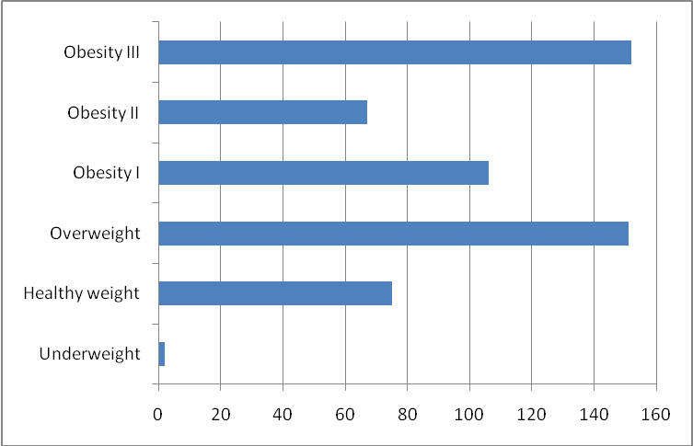

A subdivision of the obesity III subgroup shows that many of this group of patients are within working age (graph 2) i.e.65 years or below.
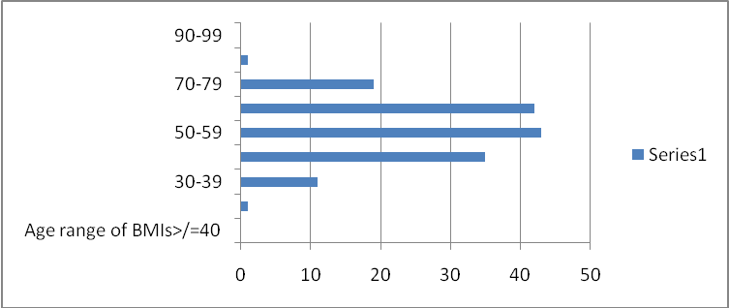

Severe obesity affects the working of the lymphatics and will worsen existing levels. Whilst management will temporarily improve the situation, research has shown that those who are overweight are more likely to rapidly lose the benefit of treatment. Many of these patients also have mobility issues compounding the problem, as confirmed by the 2010 audit of the patients attending the complex clinic. Currently, this patient group utilise a large percentage of clinical time and raise the potential risk for manual handling trauma to either patient or therapist.

Network actions:
- A GP postcard with essential diagnostic and referral information aimed to also encourage the concurrent, or prior, referral to obesity clinics (dietitian/ clinical psychologist services) and rehabilitation services along with the referral to the lymphoedema teams
- A LNNI obesity pathway (2011), increased facilitation into trust and council led activity schemes/ weight management guidance and the move towards more self-led care.
- MLAs/political parties have been lobbied to enquire about access to obesity services which are currently unavailable regionally
- LNNI purchase of bariatric equipment
- Domiciliary handling risk assessment and equipment recommendation
- Representation on BLS obesity sub-committee

7.5 Education developments

A key aim of the network is to improve diagnostic skills and the facilitation of early referral, thereby influencing the chronic disease pattern and ultimately the prevalence. Whilst the University of Ulster undergraduate programme has been embedded into Nursing, Physiotherapy, Occupational therapy, Podiatry and Radiotherapy, it has continued to prove challenging with Queen’s University Belfast and the private sector This input is recognised as a long term investment in relation to Lymphoedema. The Lymphoedema Support Network (national patient group) has developed a free on-line tool (via the British Medical Journal) which has been shared with the QUB Medical School for consideration

7.6 Frameworks (cancer and cardio vascular)

The Network has submitted reports for the cardio vascular and cancer frameworks. The standards address access to “best offered” care, patient information (both awareness information prior to developing lymphoedema and adjunct information provided whilst having lymphoedema management). Information provision at time of treatment should progress rapidly in all teams. The offer of “at risk” information is dependent upon surgical and other teams, but this has been developed and printed by LNNI, and circulated to all potential referrers for distribution to at risk groups.

The cancer standard also addresses the issues of lymphoedema risk inclusion in the consent process and the use of screening techniques by surgical teams to ensure diagnosis and referral. Whilst all Trusts now include lymphoedema in the consent process, there is a great variation in progress regarding screening: the Western and Northern Trusts have secured band 3 funding for a screening role, Belfast and South Eastern Trusts are involved in a clinical trial, and the Southern Trust is still in discussion.

7.7 Long Term Conditions (LTC) Management Model of Work

The network recognises the need to continue to support the developing role of the expert patient via a more formal LTC model. Membership of the LTCANI will aid this initiative to build upon the current work: education programmes with band 3 support. LNNI will also liaise with the Scotland group which have been awarded project funding to pilot a scheme (report due September 2012).

For further information on the LNNI Board, please follow this link: www.lnni.org

8.0 Work Plan 2012/13
Appendix A

Appendix A

LNNI Work Plan
June 12 - March 13

Agreement Cover Sheet

This work programme has been agreed by:

Chair of LNNI Clare McGartland

Date agreed 19th June 2012

LNNI members agreed the report on 19th June 2012

Annual report review date AGM, June 2013
Programme headings | Key projects/tasks | Progress |  | Current status | Jun-12 | July -12 | Aug -12 | Sept -12 | Oct -12 | Nov -12 | Dec -12 | Jan -13 | Feb -13 | Mar -13
1. Governance
 | i. Terms of reference & constitution for board and local trust networks | Last reviewed May 2010 |  |  |  | Review TOR etc
 | ii. Standards, targets and new policies | Frameworks:  Reports for cancer and cardio vascular frameworks submitted.  Review both March 12 , and draft new vascular KPIs for 2013 document  Obesity Policy (2011). Shared with Dept, ILF and BLS April.  Monitor Lymphdat BMI scores. Report at each Board meeting.  Liaise with BLS obesity group |  |  | New bariatric equip to arrive | Draft new vascular KPIs | Agree new vascular KPIs |  |  |  | Report of NP BMIs at Board |  |  | Report on access target at board meeting.  Review frameworks’ KPI data
 | iii. Monitor resources including finance | To be reported at each Board meeting in trust reports - leads |  |  | Board report |  |  | Board report |  |  | Board report |  |  | Board report
 | iv. Incident & complaints monitoring | To be reported at each Board meetings - protocol / line of comms agreed for information to be released from each trust to network - leads. |  |  |  |  |  | Board |  |  | Board |  |  | Board
 | v. Board meetings | Minutes & agendas ratified by board at following meeting & added to website – JR/DS |  |  | Sign off and up load |  |  | Sign off and up load |  |  | Sign off and up load |  |  | Sign off and up load
2. Service development
 | i. Report on existing services mapping | Mapping report complete – ratified by Board Dec 09 (Southern, South Eastern, Northern & Belfast HSC Trusts).  Western Trust 2011  Project complete
 | ii. Patient database  Lymphdat | Population began May 10.  2nd Demographic/aetiology report – for June 12 AGM.  Continue to develop reports and letters facilities  Report on BMIs at each Board |  |  | For sign off of report at AGM |  |  |  |  |  |  |  |  | Demographic/aetiology report 2013
 | iii. Complex clinics | Clinic protocol, booking system & plan agreed with clinical team. Version 5.0 of policy ratified.  Freq reduced further to every 5 months in response to learning and patient need.
 | iv. Clinical practitioner register | Service mapping tool will inform. Monitor - JR
 | v. Education strategy | Framework for strategy ratified by board (AGM June 09) and by public consultation via website.  Update work prog for AGM June 12:  - Undergrad  - specialist  - awareness |  |  | UU  Nursing  students  COBAN course  ILF conf | Review new ILF practice policy  Possible GAIN application | BLS children’s event | MEDI visit for leads | Study days – BT/SE & ST  Awareness trg  BLS conf |  |  | COBAN intro course TBC | Dermatology course
 | vi. Long Term Conditions model development | Development of LTCs model for region to build upon expert patient model |  |  | Agree to project at AGM  LTCANI meeting  Review current local work | Create links with Scottish Team  Review literature in prep | Scottish report due out – review for learning | Begin drafting model
3. Communication
 | i. Website maintenance | Update news, events & circulate newsletter |  |  | Website maintenance fee due | Annual report circulated |  |  | Autumn Newsletter circulated |  |  |  |  | Spring newsletter circulated
 | ii. Patient information leaflets | New adjuncts published Mar 11 for use with teams.  Purchased additional LSN information  All information up to date and available
 | iii. Stakeholders and external relationships | 250 Stakeholders registered. Leads to continue to encourage registration.  Membership of the International Lymphatic Framework ILF(May 11) |  |  |  | ILF conf
 | iv. Stakeholder events | Continued ST, NT, WT and SET events- leads
 | v. Six month board report | Reduced to annual report as network set up and business on-going - Complete
 | vi. Communication strategy | Framework for strategy ratified (AGM 09)+annual review:.  - BJN article  - framework submissions  - obesity policy  -Liaison with private health care institutions  - QUB liaison  - newsletters  -intranet articles  -BLS committee  -LTC Alliance  -cross border liaison  -Physio Works development (commissioning doc) |  |  | BJN article  Donegal meeting  BMI report  Physio Works draft 1 | Draft new Vascular KPIs  BLS committee  LTCA meeting | Finalise new KPIs |  | BLS committee  /conf  Launch of Physio Works doc | LTCA meeting  LNNI newsletter  Launch of Physio Works doc |  |  |  | Framework KPI reports drafted
 | viii. Annual report | Due June 12 AGM (JR) |  |  | Sign off
 | i. Audit programme to monitor practice against agreed standards & targets | 1. Audit based on CREST standards & targets. Remaining 3/46 dependent on QoL research. Lymqol tool instigated 2012 by all trusts  2. Cancer Action Team (national) CAT EBP Pathway audit.  Pathway being reviewed by NCAT July 12 |  |  |  | NCAT pathway review – LNNI to participate in review
 | ii. User satisfaction & focus groups | Patient satisfaction audits  initial audit: Dec 11- Feb 12  Continued communication with NILSG/LSNI |  |  |  |  |  |  |  | NILSG/LSNI AGM |  |  | Repeat Pt satisfaction audits |  |  |  |  |  |  |  | New intra trust PPI groups | New intra trust PPI groups
 | iii. Monitor action plans | Reports ratified by Board Continuous updates with service managers – include in Board e-mails (with agreed minutes) |  |  |  | Agreed March mins widely circulate
5. Research
 | Research  i. Clinical practice | Screening of breast cancer pts using bioimpedence |  |  | Board report | On-going recruitment |  |  |  |  |  |  |  | Annual report for Friends of CC
 | ii. Epidemiology | Initial demographic and aetiology report using Lymphdat data to highlight local trends. |  |  | 2nd Lymphdat report to be signed off at AGM |  |  |  |  |  |  |  |  | Prepare 3rd year report
 | iii. Quality of life study | Work ongoing with Rachel Holland and psychology post grad. Bursary agreed by Board (Dec 09). Continued delay due to staffing issues in clinical psychology. Will inform QoL tool. |  |  | Ethics preparation delayed again due to illess of lead
 | iv. Laser lit review | Undergrad sponsorship/mentoring re dissertation |  |  | Published by BLS | Publish by ACPOPC
Not yet started
Behind schedule
On schedule
Ahead of schedule
Completed
 | This project plan is signed on behalf of the LNNI Board by:
 | Chair: |  | Signature: |  |  |  | Date:
 | Ms Clare McGartland |  | _______________________ |  |  |  | 19th June 2012

