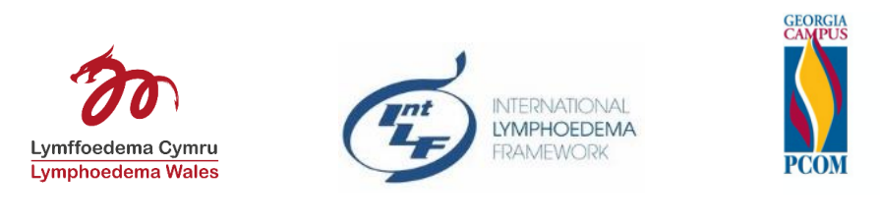
What additional education resources would help you feel more confident in treating Children and Young People with Lymphoedema?
Why:
- Over 500 people, from all over the world, told ILF about the impact of Lymphoedema on quality of life for Children and Young People and those around them (ILF 2021-2022).
- Health Care Professionals have described feeling inadequately prepared to treat and support Children and Young People with Lymphoedema (Lymphoedema Wales 2021; ILF 2017-2021).
- Children and Young People with lymphoedema have often searched for a diagnosis for years and had inadequate treatment before finding a health professional who understands lymphoedema in children (Lymphoedema Wales 2021; ILF 2017-2021).
- We hope that the findings from the project can inform future developments by lymphedema programme educators, academic organisations and corporate and charity partners who do so much to support our specialism

Who is it for? If you are a health professional treating lymphoedema in CYP or an academic/researcher working in this area, this survey is for you.
How: English language survey https://www.surveymonkey.co.uk/r/CYPEDNEED
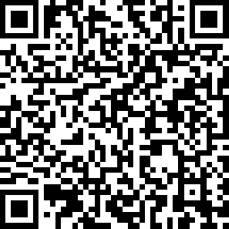
Spanish survey https://www.surveymonkey.co.uk/r/CYPSPAIN
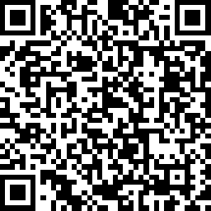
French, Turkish, and Welsh language surveys available from Rhian.Noble-Jones@wales.nhs.uk
When: March 2022 – June 2022
What to expect: this anonymous and detailed survey is designed to give you the opportunity to really consider the breadth of knowledge and experience needed to treat CYP with lymphoedema. Therefore it may take up to 20 minute to complete.
Further information: Ethical consideration for the project was undertaken by the Joint Study Review Committee (JSRC) and it is sponsored by Swansea Bay University Health Board, NHS Wales, UK (January 2021). The survey also has ethical approval from Philadelphia College of Osteopathic Medicine, USA (February 2022).
The survey was developed by Lymphoedema Wales through literature search (Noble-Jones, ILF conference, Denmark 2021) and focus group with UK experts the Children’s Lymphoedema Special Interest Group (CLSIG) of the British Lymphology Society, and in design cycles with ILF board members. Translated to Turkish by Prof. Pinar Borman, MD; Spanish by through co-researcher in USA, Dr Shelley DiCecco, PT, and into Welsh by Dr Rhian Noble-Jones, PT.
Project lead: Dr Melanie Thomas, ILF Board member and Clinical Director of Lymphoedema Wales, UK. Co-researcher in Wales: Karl Hocking. Contact for more information: Rhian.Noble-Jones@wales.nhs.uk

